R Output
> library(NCStats)
> library(MASS)
> sp <- read.table("SoilPhosphorous.txt",head=T)
> str(sp)
`data.frame': 24 obs. of 3 variables:
$ soil: Factor w/ 2 levels "sandstone","shale": 2 2 2 2 2 2 2 2 2 ...
$ topo: Factor w/ 4 levels "hilltop","north",..: 4 4 4 2 2 2 3 3 3 ...
$ phos: int 98 172 185 78 77 100 117 54 96 83 ...
> attach(sp)
> lm1 <- lm(phos~soil*topo)
> Levenes(lm1)
Levene's Test for Homogeneity of Variance
Df F value Pr(>F)
group 7 0.3741 0.9043
16
> plot.resid(lm1,loess=F)
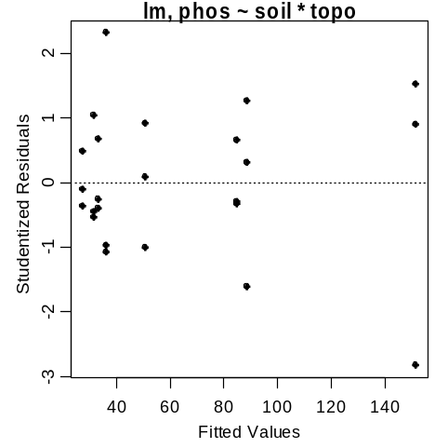
> ad.test(lm1$residuals)
Anderson-Darling normality test
data: lm1$residuals
A = 0.2126, p-value = 0.8351
> outlier.test(lm1)
max|rstudent| = 2.824098, degrees of freedom = 15,
unadjusted p = 0.01282056, Bonferroni p = 0.3076934
Observation: 1
> anova(lm1)
Analysis of Variance Table
Response: phos
Df Sum Sq Mean Sq F value Pr(>F)
soil 1 17876.0 17876.0 22.9818 0.0001988 ***
topo 3 9693.8 3231.3 4.1542 0.0235128 *
soil:topo 3 11390.8 3796.9 4.8814 0.0134826 *
Residuals 16 12445.3 777.8

> TukeyHSD(lm1,which="soil:topo",ordered=T)
Tukey multiple comparisons of means
95% family-wise confidence level
factor levels have been ordered

$`soil:topo`
diff lwr upr p adj
sandstone:hilltop-sandstone:valley 4.000000 -74.83945 82.83945 0.9999996
sandstone:north-sandstone:valley 5.666667 -73.17279 84.50612 0.9999954
shale:hilltop-sandstone:valley 8.666667 -70.17279 87.50612 0.9999164
sandstone:south-sandstone:valley 23.333333 -55.50612 102.17279 0.9634477
shale:north-sandstone:valley 57.333333 -21.50612 136.17279 0.2553970
shale:south-sandstone:valley 61.333333 -17.50612 140.17279 0.1939149
shale:valley-sandstone:valley 124.000000 45.16055 202.83945 0.0010901 *
sandstone:north-sandstone:hilltop 1.666667 -77.17279 80.50612 1.0000000
shale:hilltop-sandstone:hilltop 4.666667 -74.17279 83.50612 0.9999988
sandstone:south-sandstone:hilltop 19.333333 -59.50612 98.17279 0.9868458
shale:north-sandstone:hilltop 53.333333 -25.50612 132.17279 0.3302394
shale:south-sandstone:hilltop 57.333333 -21.50612 136.17279 0.2553970
shale:valley-sandstone:hilltop 120.000000 41.16055 198.83945 0.0015229 *
shale:hilltop-sandstone:north 3.000000 -75.83945 81.83945 0.9999999
sandstone:south-sandstone:north 17.666667 -61.17279 96.50612 0.9921843
shale:north-sandstone:north 51.666667 -27.17279 130.50612 0.3653087
shale:south-sandstone:north 55.666667 -23.17279 134.50612 0.2849492
shale:valley-sandstone:north 118.333333 39.49388 197.17279 0.0017519 *
sandstone:south-shale:hilltop 14.666667 -64.17279 93.50612 0.9974607
shale:north-shale:hilltop 48.666667 -30.17279 127.50612 0.4336685
shale:south-shale:hilltop 52.666667 -26.17279 131.50612 0.3440022
shale:valley-shale:hilltop 115.333333 36.49388 194.17279 0.0022566 *
shale:north-sandstone:south 34.000000 -44.83945 112.83945 0.8004647
shale:south-sandstone:south 38.000000 -40.83945 116.83945 0.7055269
shale:valley-sandstone:south 100.666667 21.82721 179.50612 0.0078827 *
shale:south-shale:north 4.000000 -74.83945 82.83945 0.9999996
shale:valley-shale:north 66.666667 -12.17279 145.50612 0.1311746
shale:valley-shale:south 62.666667 -16.17279 141.50612 0.1762731

> plot.twoway(lm1,change.order=T,xlab="Topographic Location",
+ ylab="Mean Phosphorous Level")
> add.sig.letters(lm1,change.order=T,
+ lets=c("a","a","a","ab","a","ab","a","b"),pos=c(1,3,1,3,1,1,3,1))
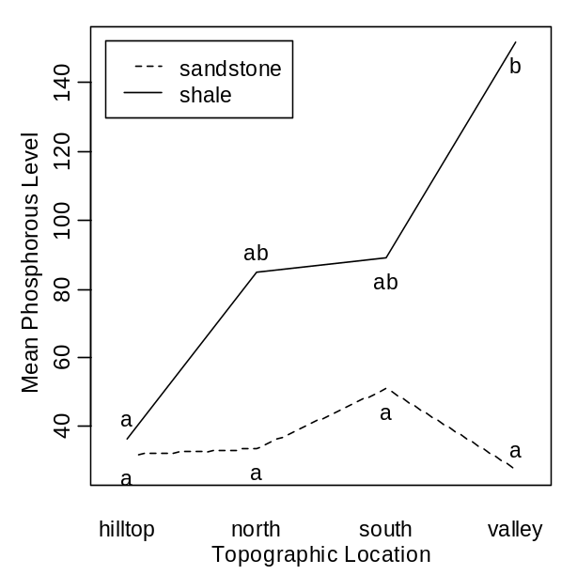

# next commands not required in this example because there is an interaction
# effect. These commands for main effects are, thus, shown just as an
# illustration

> TukeyHSD(lm1,which="topo",ordered=T)
Tukey multiple comparisons of means
95% family-wise confidence level
factor levels have been ordered
Fit: aov(formula = mdl)
$topo
diff lwr upr p adj
north-hilltop 25.16667 -20.901774 71.23511 0.4258704
south-hilltop 36.00000 -10.068441 82.06844 0.1557747
valley-hilltop 55.66667 9.598226 101.73511 0.0154200 *
south-north 10.83333 -35.235108 56.90177 0.9058377
valley-north 30.50000 -15.568441 76.56844 0.2691848
valley-south 19.66667 -26.401774 65.73511 0.6228505

> plot.twoway(lm1,which="topo",xlab="Topographic Location",
+ ylab="Mean Phosphorous Level")
> add.sig.letters(lm1,which="topo",lets=c("a","ab","ab","b"),pos=c(3,3,3,1))
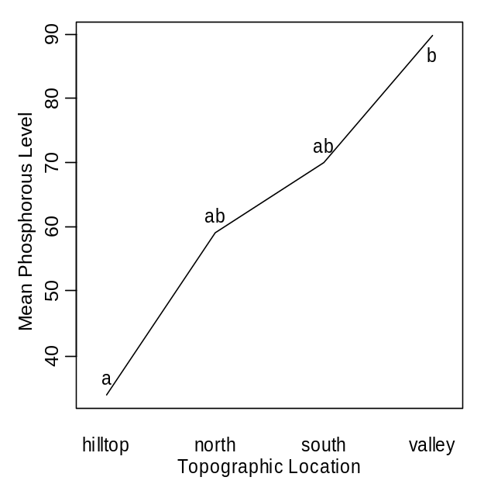

R Commands

library(NCStats)
library(MASS)
sp <- read.table(“SoilPhosphorous.txt”,head=T)
str(sp)
attach(sp)
lm1 <- lm(phos~soil*topo)
Levenes(lm1)
plot.resid(lm1,loess=F)
ad.test(lm1$residuals)
outlier.test(lm1)
anova(lm1)
TukeyHSD(lm1,which="soil:topo",ordered=T)
plot.twoway(lm1,change.order=T,xlab="Topographic Location",ylab="Mean Phosphorous Level")
add.sig.letters(lm1,change.order=T,lets=c("a","a","a","ab","a","ab","a","b"),pos=c(1,3,1,3,1,1,3,1))

# next commands not required in this example because there is an interaction
# effect. These commands for main effects are, thus, shown just as an
# illustration

TukeyHSD(lm1,which="topo",ordered=T)
plot.twoway(lm1,which="topo",xlab="Topographic Location",ylab="Mean Phosphorous Level")
add.sig.letters(lm1,which="topo",lets=c("a","ab","ab","b"),pos=c(3,3,3,1))

